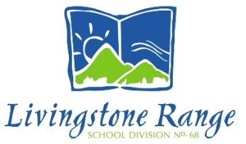

DR. LLOYD CAVERS

STUDENT LEADERSHIP SCHOLARSHIP

The purpose of this scholarship is to recognize the contributions made by a student leader in Livingstone Range School Division. The recipient’s leadership abilities will have had a positive impact, primarily at the school, but also in the wider community. The student will be graduating from Grade 12 in his or her chosen program.

This $1,000 scholarship will be awarded annually by the Livingstone Range School Division Board of Trustees to a recipient nominated by his or her school and selected by a committee consisting of two Trustees and one Central Office Administrator. $200.00 will be awarded to each of the other candidates.

Submission Details for the 2020 Award:

Each high school in the Livingstone Range School Division is invited to submit the name of one candidate by May 15, 2020. The school’s submission on behalf of its candidate will be limited to a one-page covering letter and a maximum of two pages to include the student’s school activities, community activities, personal qualities, and any other comments he or she wishes to make (see attached Selection Criteria) and template.

Please forward your nomination in a sealed enveloped marked “Confidential” to:

Lloyd Cavers Student Leadership Scholarship
c/o Nikki Lytwyn
Livingstone Range School Division
P. O. Box 1810
Fort Macleod, AB T0L 0Z0

